TSDS L1.5 Filters

L1.5 Filters are data validation checks against data loaded into the LEA’s IODS and does not mean the data is wrong, just needs to be verified.

- Log into TEAL.
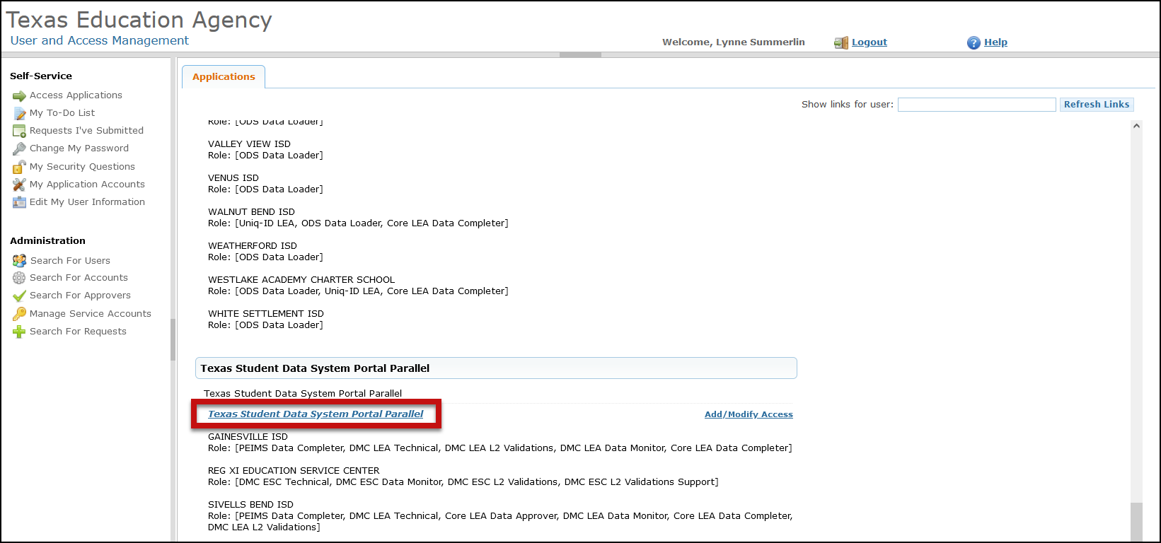
- Click on Texas Student Data System Portal Parallel link.

- Click on Manage IODS.
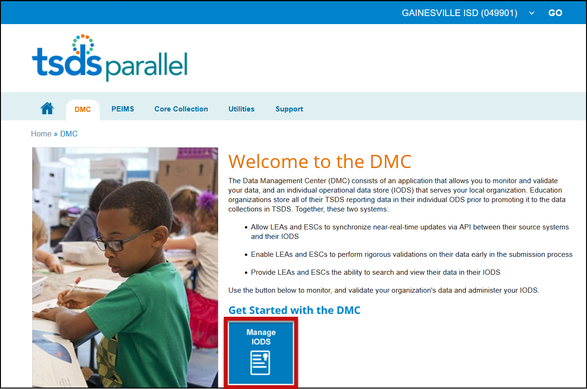

- On the Data Management Center (DMC) screen select Monitor Validations > View L1.5 Filter Details.

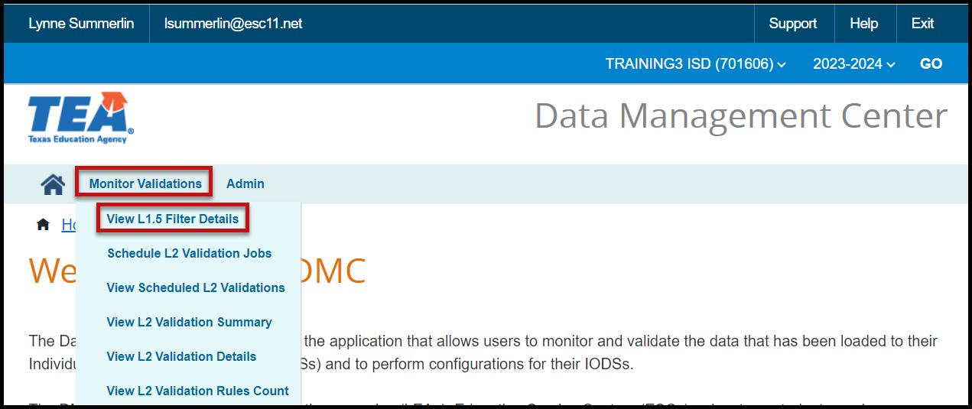

- The Monitor Validations screen appears.

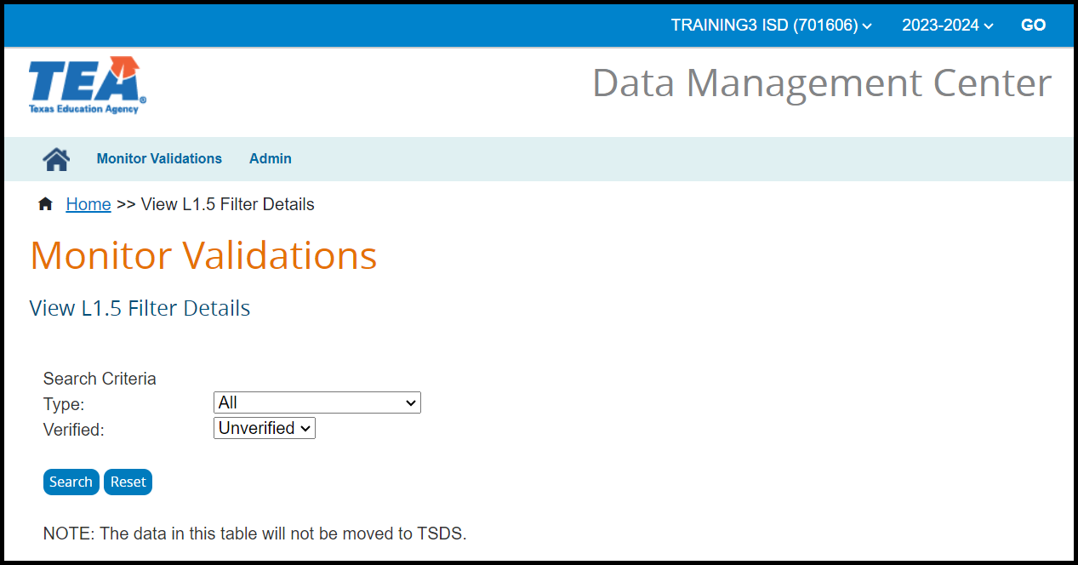

- Under Search Criteria select a Type from the pull-down menu for the filter. Options include Course ID, Descriptor Value, UID-Staff/Student, and Do Not Report - Staff/Student.

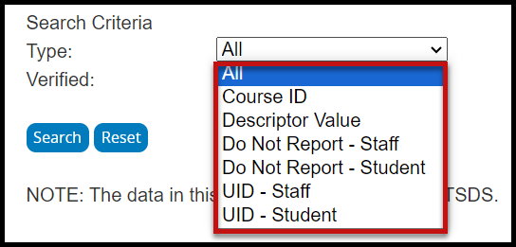

- Under Search Criteria select a Verified status from the pull-down menu for the filter. Options include All, Verified, and Unverified.

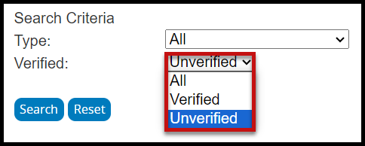

- Click Search.

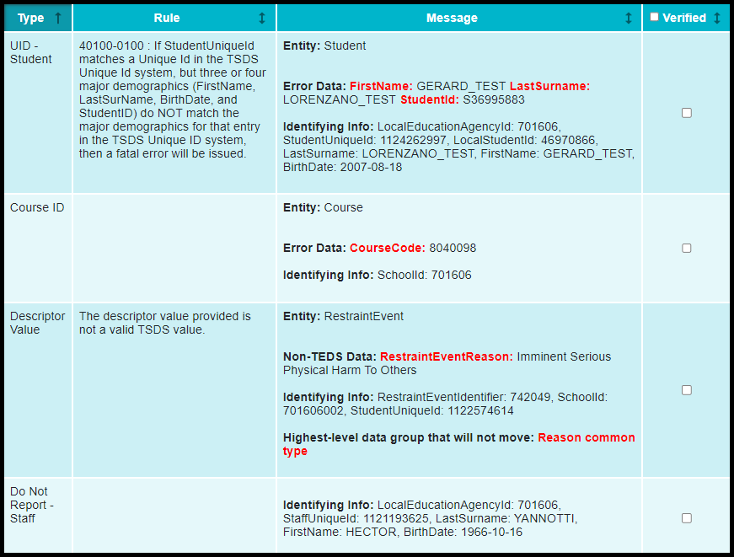

- After reviewing the data and making any necessary changes in the database, mark the item(s) as verified by either using the checkbox to verify all or selecting the individual checkbox next to the item(s) that have been verified.
- The information on this screen can be printed or saved as an XLSX file.
TIP: L1.5 Verified means that the user has looked at the filter (error) and has made note of the issue, correction has been made, or no action needs to be taken.

Validation Result Sample Scenarios
Course ID:
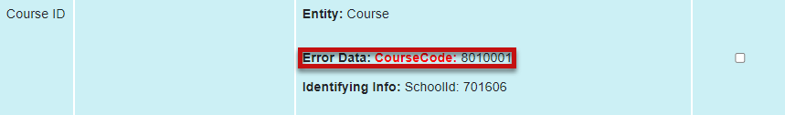
Course ID is not a valid TEDS course Descriptor (Service ID) and is not in the correct format (8 characters). If the course is not to be reported in a TSDS submission/collection or has been corrected in the software for the next upload, mark this course as verified.

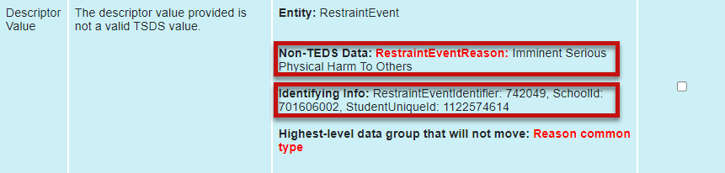
Descriptor Values:
The RestraintEventReason is being reported with the Short Description (Imminent Serious Physical Harm to Others) instead of the Descriptor Code (02). This might be an item that must be mapped or corrected with the software vendor. Identifying Info is provided to assist with locating the issue in the software. Mark verified once the issue has been noted for correction or has been corrected.

Unique ID:
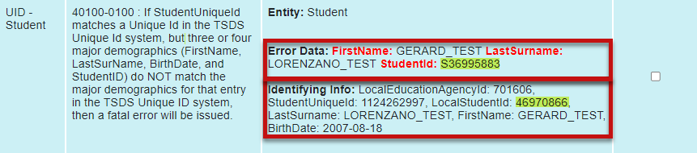
The student’s Social Security or “S” number (LocalStudentID) does not match the one assigned to the student in TSDS Unique ID. Mark verified once the issue has been noted for correction or has been corrected.

Do Not Report:
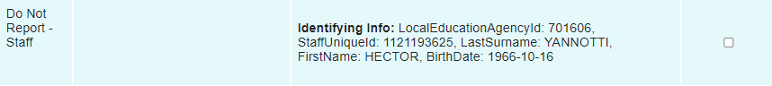
A non-district staff member is entered in the software but is only for local use and not to be reported to PEIMS. The staff member is flagged in the software to not report. The staff member is pulling from the software and due to the flag, they will not move into TSDS, but will remain in the LEAs IODS for local use. Mark verified once the record has been reviewed.

